# Data-Driven Innovations In Supply Chain Management With Qlik Insights

**Problem Identification:**

The primary objective of this project is to revolutionize supply chain management by leveraging Qlik's advanced data analytics capabilities. This initiative aims to optimize key areas of supply chain operations, including logistics, forecasting, and inventory management. By using data-driven insights, the project seeks to enhance overall operational efficiency and responsiveness. The goal is to transform traditional supply chain processes to meet the demands of modern business environments, ensuring timely and cost-effective delivery of goods and services.

**Business Requirements****:**

1. **Data Integration Strategy**: Develop and implement a comprehensive strategy to aggregate and centralize data from various supply chain sources.
2. **Visualization Capabilities**: Utilize Qlik's advanced visualization tools to create user-friendly and dynamic dashboards, providing stakeholders with clear insights into the supply chain.
3. **Historical Data Analysis**: Leverage Qlik's advanced analytics to analyze historical logistics data, identify patterns, and optimize transportation routes.
4. **Real-Time Tracking and Monitoring**: Implement solutions for real-time tracking and monitoring of goods movement to reduce lead times and minimize transportation costs.
5. **Real-Time Analytics for Decision-Making**: Utilize real-time analytics to facilitate quick decision-making in response to unforeseen events or changes in demand, ensuring a proactive and responsive supply chain.

Literature Survey:

1.Exploring data-driven innovation: What’s missing in the relationship between big data analytics capabilities and supply chain innovation? by Sabeen Hussain Bhatti, Wan Mohd Hirwani Wan Hussain, Jabran Khan, Shahbaz Sultan & Alberto Ferraris says Data-driven innovations (DDI) have significantly impacted firms’ operations thanks to the massive exploitation of huge data. However, to leverage big data and achieve supply chain innovation, a variety of complementary resources are necessary. In this study, we hypothesise that supply chain innovation (SCI) is dependent on firms’ big data analytics capabilities (BAC).

2.Sustainable Data-Driven Innovations in Supply Chains by Prof. Dr. Jao-Hong Cheng,Prof. Dr. Chung Hsing Yeh,Dr. Anne Yenching Liu.

3.Big Data Driven Supply Chain Management by Qi Li a, Ang Liu a says In the big data era, the decision making of supply chain management is increasingly driven by data instead of experience. Nevertheless, the traditional strategies of supply chain management impose many constraints to the full usage of data. This paper presents a data-driven supply chain management framework.

Social or Business Impact:

Social Impact Analysis

1. **Demographic Distribution Visualization**: Create visualizations to showcase how supply chain management impacts different demographic groups.
2. **Impact on Social Welfare Programs**: Analyze the effects of data-driven innovations in supply chain management on social welfare programs, financial inclusion, and other key areas.
3. **Correlations and Improvements**: Explore correlations between the adoption of data-driven supply chain management and improvements in social programs.

Business Impact Analysis

1. **Sectoral Impact Analysis**: Examine how data-driven innovations in supply chain management affect businesses in sectors like banking, telecommunications, and e-commerce.
2. **Impact on Sales and Efficiency**: Evaluate the impact on sales, customer onboarding processes, and overall operational efficiency.
3. **Operational Efficiency**: Assess how data-driven innovations contribute to reducing costs and improving the speed and reliability of supply chain operations.

**Data Collection & Extraction From Database****:**

Data collection is the process of gathering and measuring information on variables of interest, in an established systematic fashion that enables one to answer stated research questions, test hypotheses, evaluate outcomes and generate insights from the data. The dataset was downloaded from kaggle.com and the dataset consts of following:

1.DataCoSupplyChainDataset.

2.DescriptionDataCoSupplyChain.

3.tokenized_access_logs.

All the datasets are in .csv format where DescriptionDataCoSupplyChain.csv contains the Description of every column in the DataCoSupplyChainDataset.The DataCoSupplyChainDataset consists of the following columns:

1. Type
2. Days for shipping (real)
3. Days for shipment (scheduled)
4. Benefit per order
5. Sales per customer
6. Delivery Status
7. Late_delivery_risk
8. Category Id
9. Category Name
10. Customer City
11. Customer Country
12. Customer Email
13. Customer Fname
14. Customer Id
15. Customer Lname
16. Customer Password
17. Customer Segment
18. Customer State
19. Customer Street
20. Customer Zipcode
21. Department Id
22. Department Name
23. Latitude
24. Longitude
25. Market
26. Order City
27. Order Country
28. Order Customer Id
29. order date (DateOrders)
30. Order Id
31. Order Item Cardprod Id
32. Order Item Discount
33. Order Item Discount Rate
34. Order Item Id
35. Order Item Product Price
36. Order Item Profit Ratio
37. Order Item Quantity
38. Sales
39. Order Item Total
40. Order Profit Per Order
41. Order Region
42. Order State
43. Order Status
44. Product Card Id
45. Product Category Id
46. Product Description
47. Product Image
48. Product Name
49. Product Price
50. Product Status
51. Shipping date (DateOrders)
52. Shipping Mode

**Data Preparation:**

Given that the dataset has no null values and requires no preprocessing, we can proceed directly with the exploratory data analysis (EDA) and visualization steps.

1. Log into Qlik Account

* Open your web browser and navigate to the Qlik Cloud platform.
* Log in using your credentials.

2. Create a New App

* Once logged in, click on the Create new app button.
* Name the app Supply Chain Management.
* Choose Personal space for the app's storage location.
* Click on Create.

3. Load the First Dataset

* After the app is created, navigate to Data files.
* Click on Add data from files and other sources.
* Locate and select the .DataCoSupplyChainDataset file from your computer’s desktop.
* Follow the prompts to load the dataset into Qlik Cloud.
* Click on Next to proceed.

4. Load the Second Dataset

* Repeat the above process to load the second dataset:
  + Click on Add data from files and other sources.
  + Select the tokenized_access_logs file from your computer’s desktop.
  + Follow the prompts to load the dataset.
* Click on Next to proceed.

5. Combine the Datasets

* With both datasets loaded, you will need to combine them:
  + Navigate to the Data manager or Data load editor.
  + Use Qlik's association or join capabilities to combine .DataCoSupplyChainDataset and tokenized_access_logs.
  + Ensure that you correctly map the relevant fields to create a meaningful dataset for analysis.
* After setting up the associations or joins, click on Load data.

6. Verify Data Load

* After the data load is complete, verify that the datasets are combined correctly:
  + Check the Data model viewer to see the combined data structure.
  + Ensure all relevant fields are properly linked and no data is missing.

7. Prepare for Data Visualization

* With the data loaded and verified, you can now proceed to the Insights or Sheets section to start creating visualizations.
* Begin by exploring the combined dataset to identify key metrics, patterns, and trends.
* Use various Qlik visualization tools like bar charts, line graphs, pie charts, and tables to create your visualizations.

Data Visualization:

Data visualization is the process of creating graphical representations of data to help people understand and explore the information. The goal of data visualization is to make complex data sets more accessible, intuitive, and easier to interpret. By using visual elements such as charts, graphs, and maps, data visualizations can help people quickly identify patterns, trends, and outliers in the data.

* In the SupplyChainManagement ,the visualization used are in the charts field such as following :

1. KPI'S
2. Listbox
3. Pie chart
4. Bar Graph
5. Histogram

**1.Total Sales :**

* Overall sales are aound 36.78M.



**2.Total Profit Margin:**

* The total profit Margin for is 3.97M for the 36.78M of Overall sales.



**3.Global Profit Ratio**

* The Country level Global Profit Ratio indicates the Estados Unidos is with 13.6% , Franica with 8.3 % ,mexico with 7.6 % ,Alemania with 4.9%,Brasil with 4.7 %, and other has highest percentage ratio with 45.9% among the Global Profit Ratio.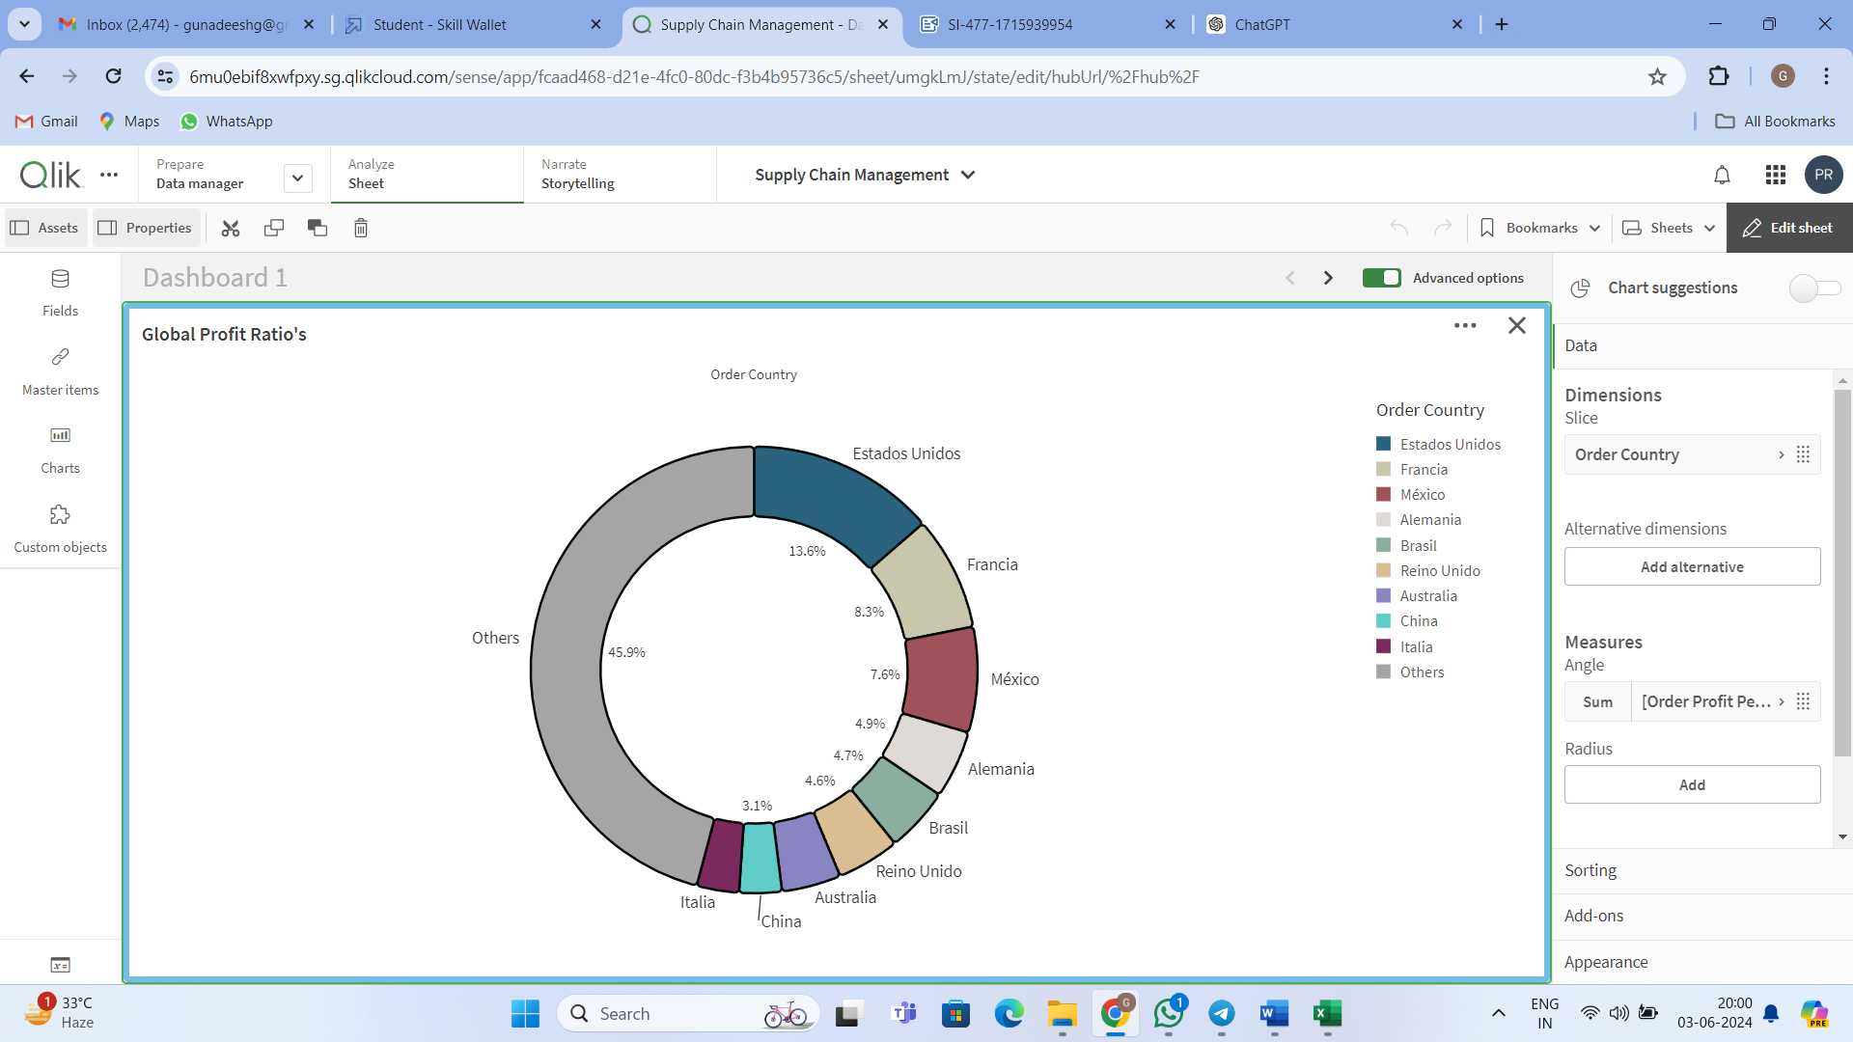

**4.Total Items placed by customer in country:**

* Toal Items placed by customer in country is 61.5 % of EE.UU and 38.5 % for the Puerto Rico.

**5.Total Items placed by a state:**

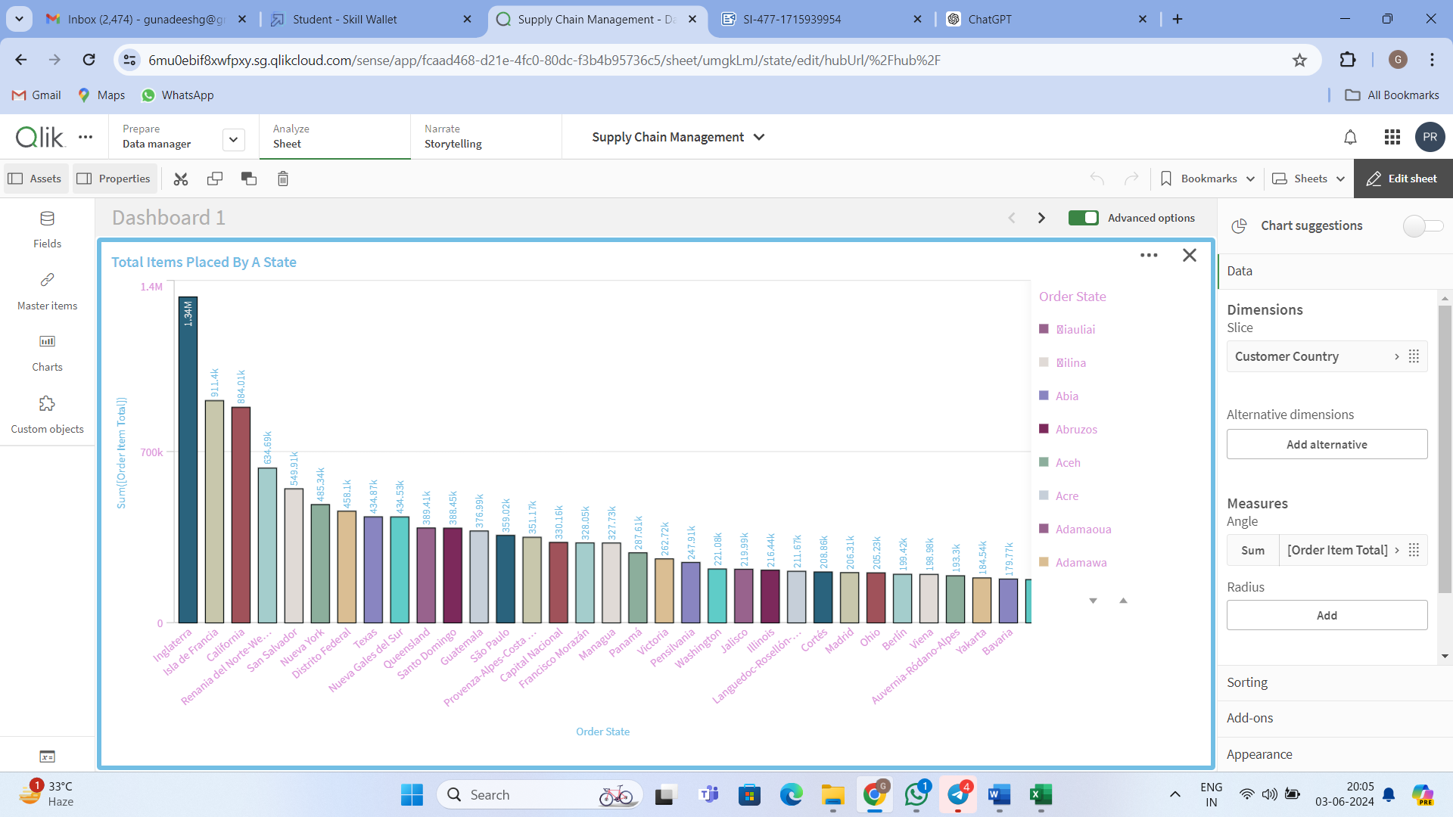

**6.Analysis on customer segment:**

* As observed ,Consumer has highest percentage with 93.5k next following Corporate with 54.7k and last Home Office with 32.23k on analysis on customer segment.

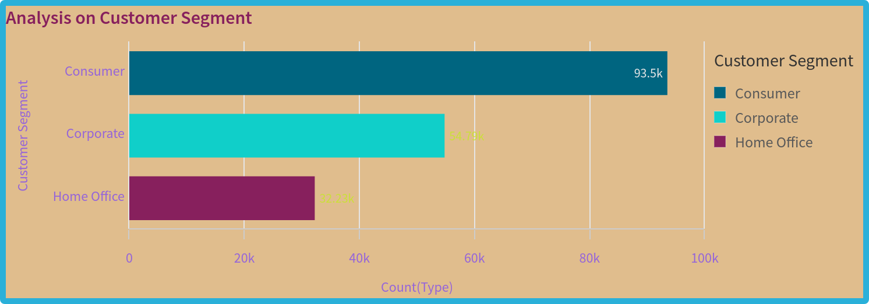

**7.Mode of payment:**

* Mode of payment has cash,bebit,payment,Transfer fileds where debit has highest with 69.3k ,next Transfer with 49.88k ,next payment with 41.73k and at last with cash only with 19.62 k.

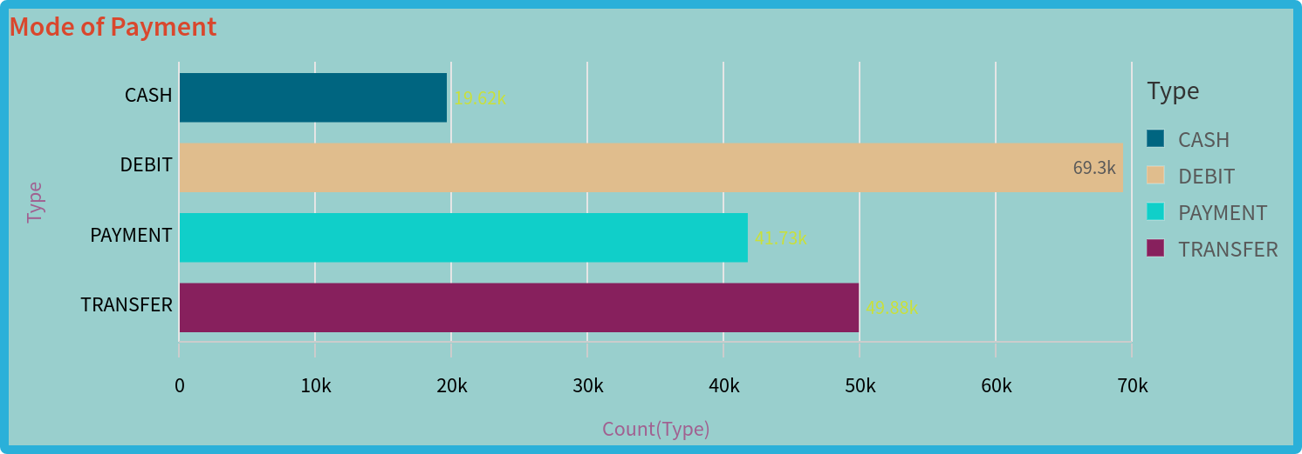

**8.Customer purchase by city:**

* The EE.UU has 111.15k and Puerto Rico has 69.37k on customer purchase by city with following countries.

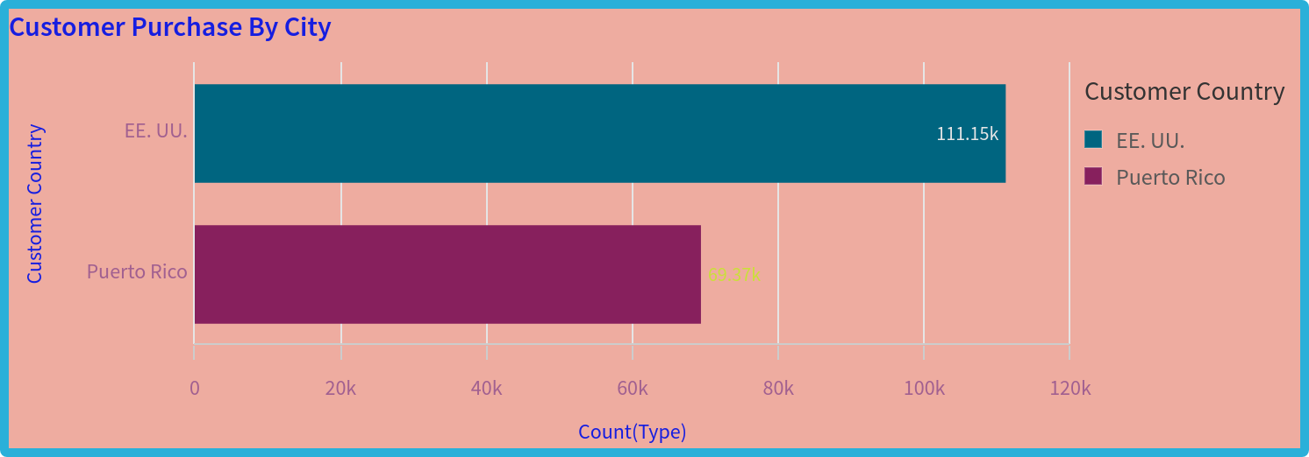

**9.Delivery status of orders:**

* Here the delivery status has recorded the late delivery with 98.98k which is the major disadvantage ,next advance shipping with 41.59k ,next 32.2k people have received the order on time and 7.75k people canceled the product shipping due to varioues reasons.

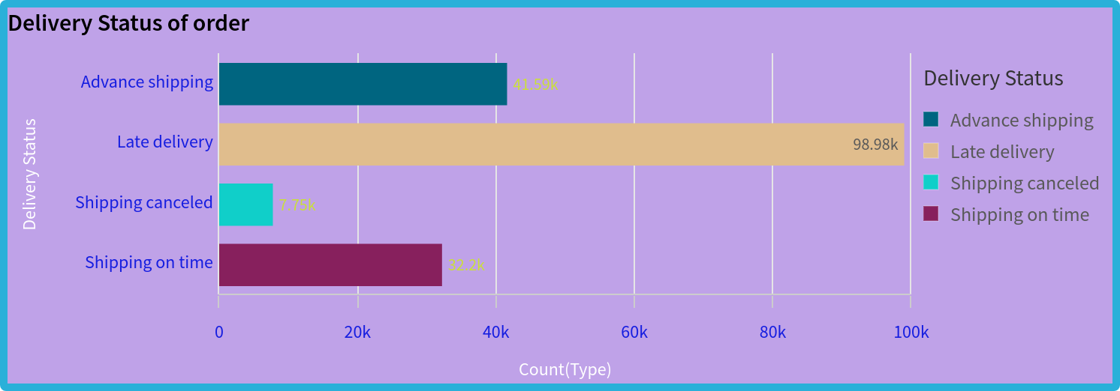

**10.Analysis on benefit per order:**

* The following graph indicates the Analysis on benefit per order where the density records with 19155.

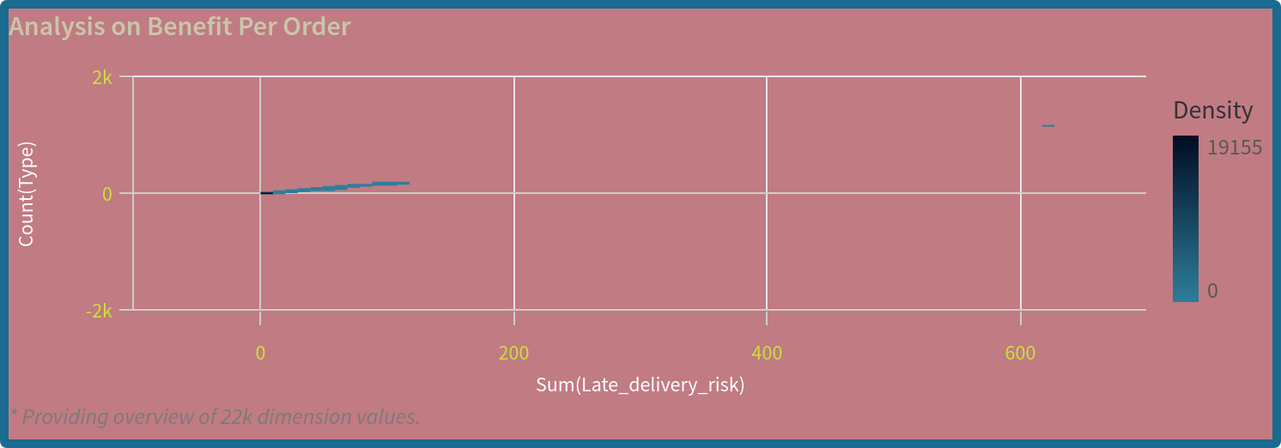

**11.Analysis on profit ratio:**

* The following graph indicates the analysis on profit ration by taking order item and frequency of item brought by the customers.

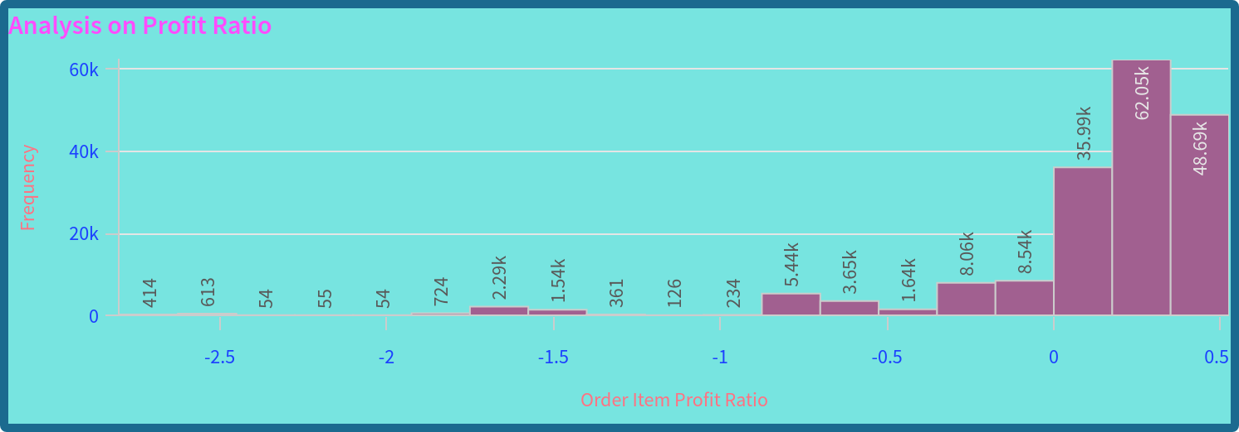

**12.Market Analysis:**

* As per Market Analysis the LATAM has 51.59 k customers,next Europe with 50.25k customers,then Pacific Asia with 41.26k ,.next USCA with 25.8k and last stands Africa with 11.61k customers.

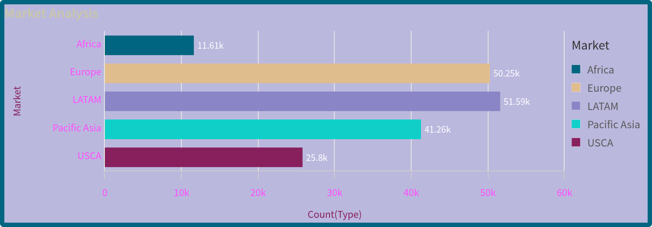

**13.Analysis on order region:**

* Central America has 28.34k ,Western Europe with 27.11k ,next South America with 14.94k ,next Oceania with 10.15k and Northern Europe and Southeast Asia with 9.79k and 9.54 k of analysis on order region.

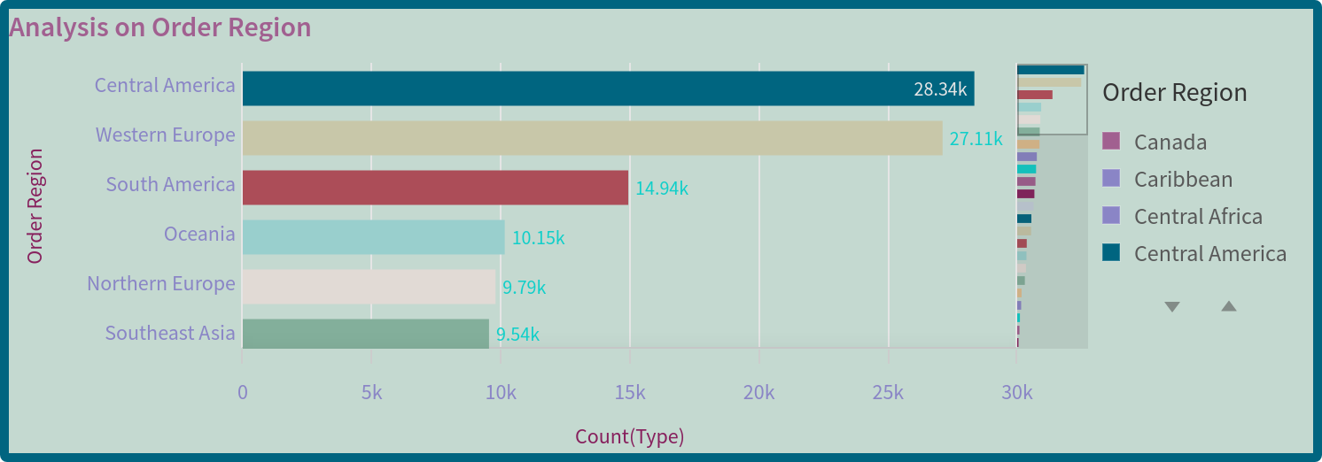

**14.Delivery Risk:**

* Delivery Risk is at 98.98k.

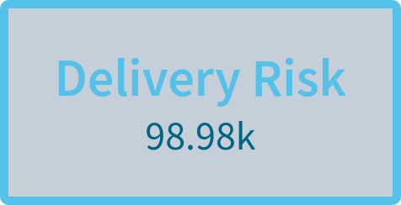

Dashboards:

A dashboard is a graphical user interface (GUI) that displays information and data in an organized, easy-to-read format. Dashboards are often used to provide real-time monitoring and analysis of data and are typically designed for a specific purpose or use case. Dashboards can be used in a variety of settings, such as business, finance, manufacturing, healthcare, and many other industries. They can be used to track key performance indicators (KPIs), monitor performance metrics, and display data in the form of charts, graphs, and tables.

**Dashboard 1:**

* The dashboard 1 consists of Data visualization's of Sales Pprofit MarginTotal Items placed by customer in country ,Total Items placed by a state,Global Profit Ratios,Delivery Risk and Fileds of listbox where slected country and options have been choosen for the dashboard 1.

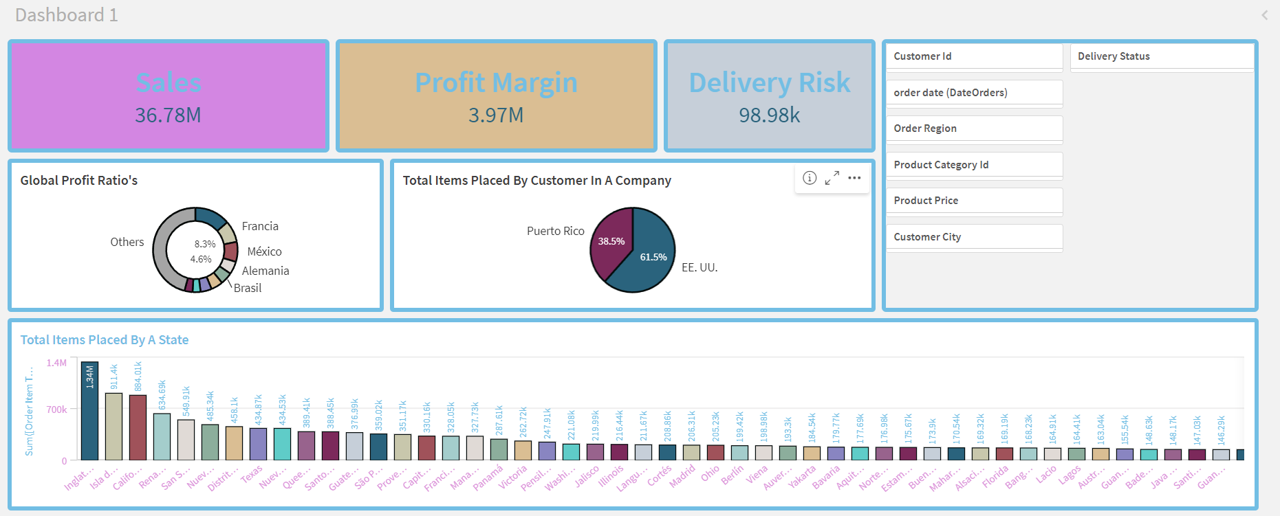

**Dashboard 2:**

* The dashboard 2 consists of Data visualization's of Analysis on customer segment,Mode of payment,Customer purchase by city,Delivery status of orders for the dashboard 2.

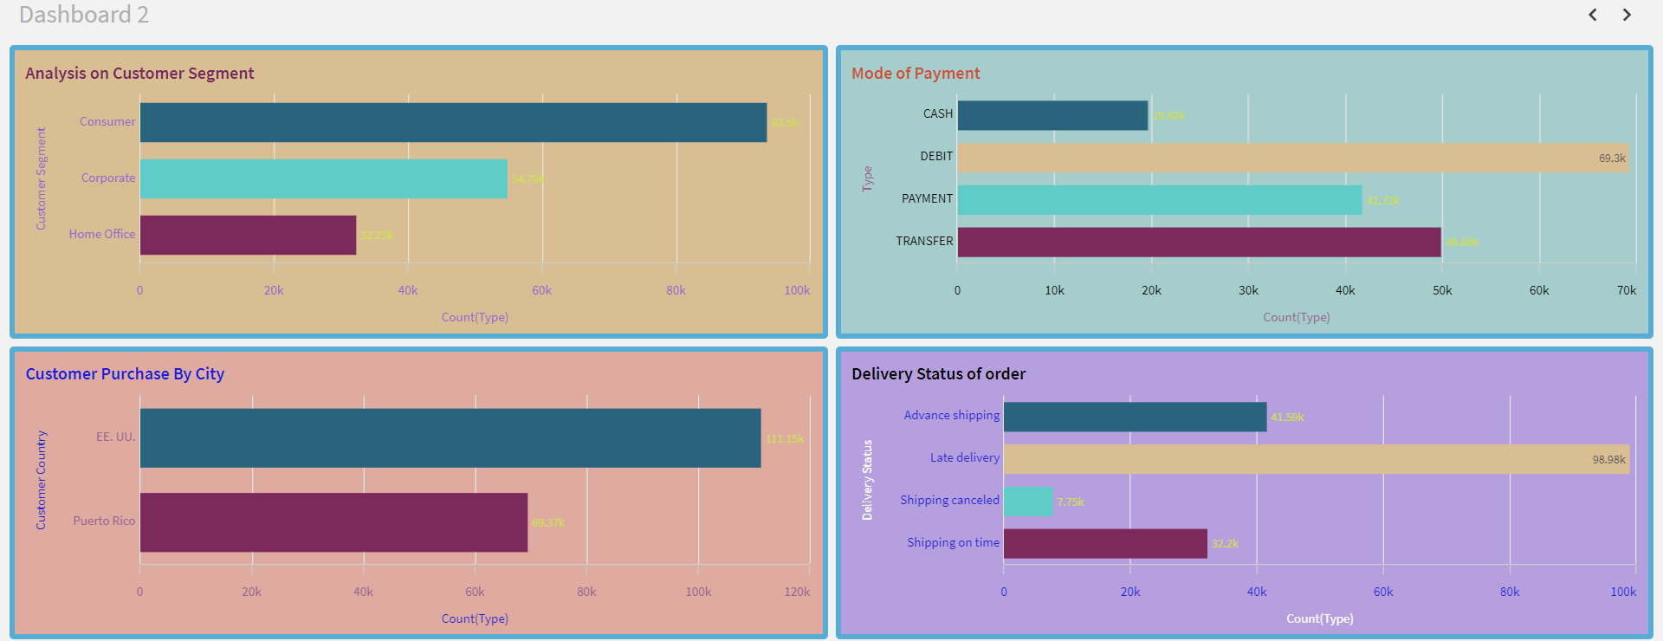

**Dashboard 3:**

* The dashboard 3 consists of Data visualization's of Analysis on benefit per order,Analysis on profit ratio,Market Analysis,Analysis on order region for the dashboard 3.

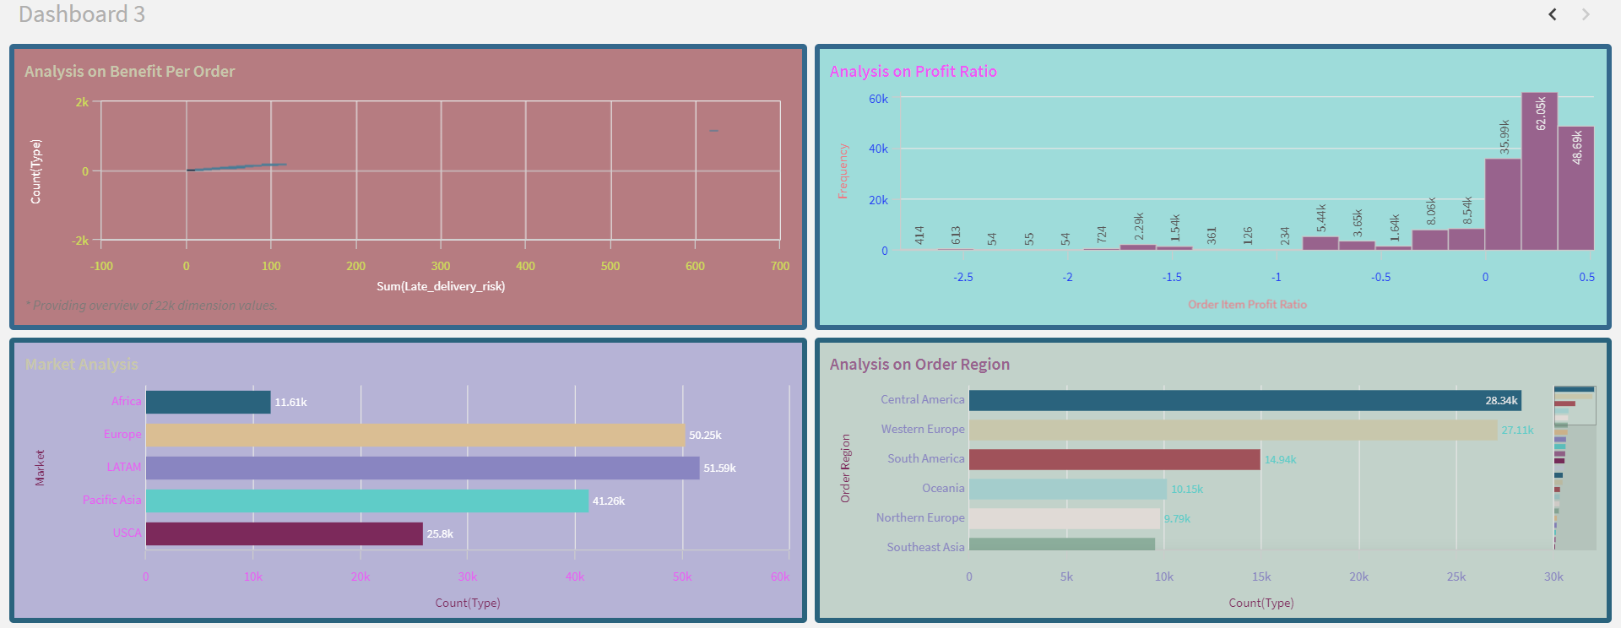

Storytelling:

A data story is a way of presenting data and analysis in a narrative format, with the goal of making the information more engaging and easier to understand. A data story typically includes a clear introduction that sets the stage and explains the context for the data, a body that presents the data and analysis in a logical and systematic way, and a conclusion that summarizes the key findings and highlights their implications. Data stories can be told using a variety of mediums, such as reports, presentations, interactive visualizations, and videos.

**Storytelling 1:**

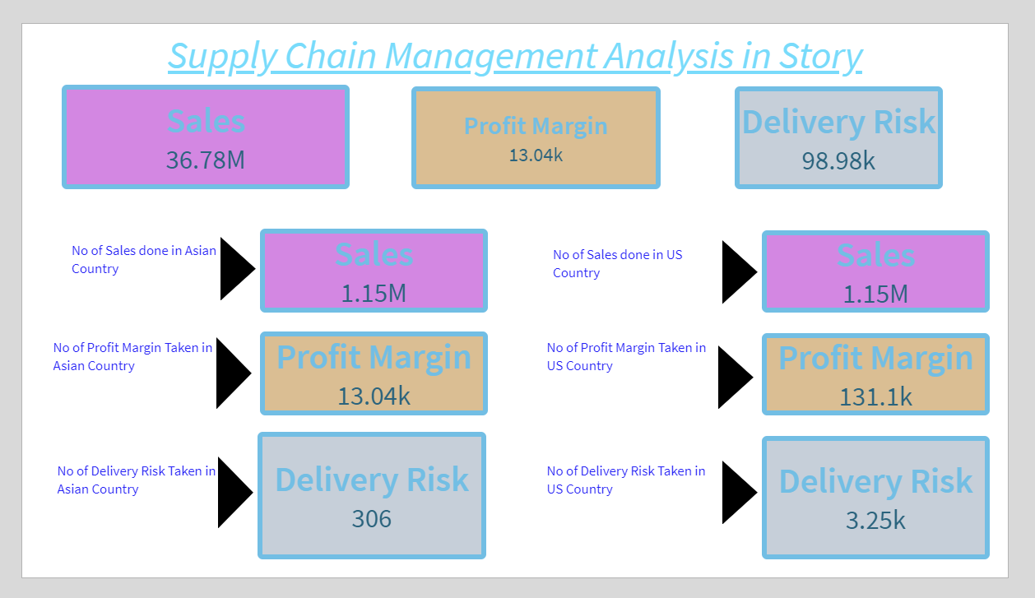**Storytelling 2:**

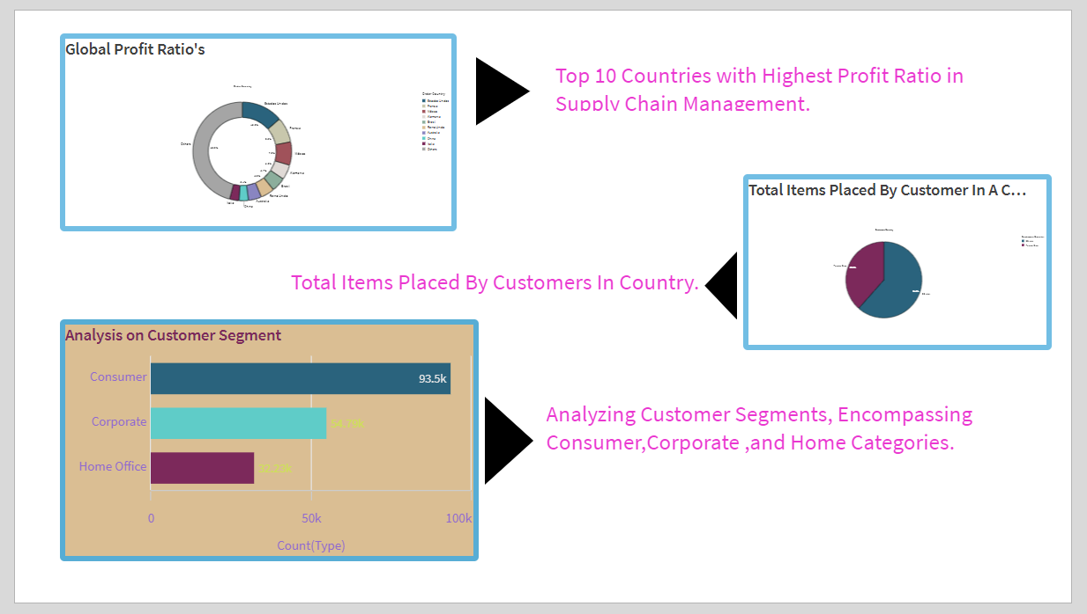

**Storytelling 3:**

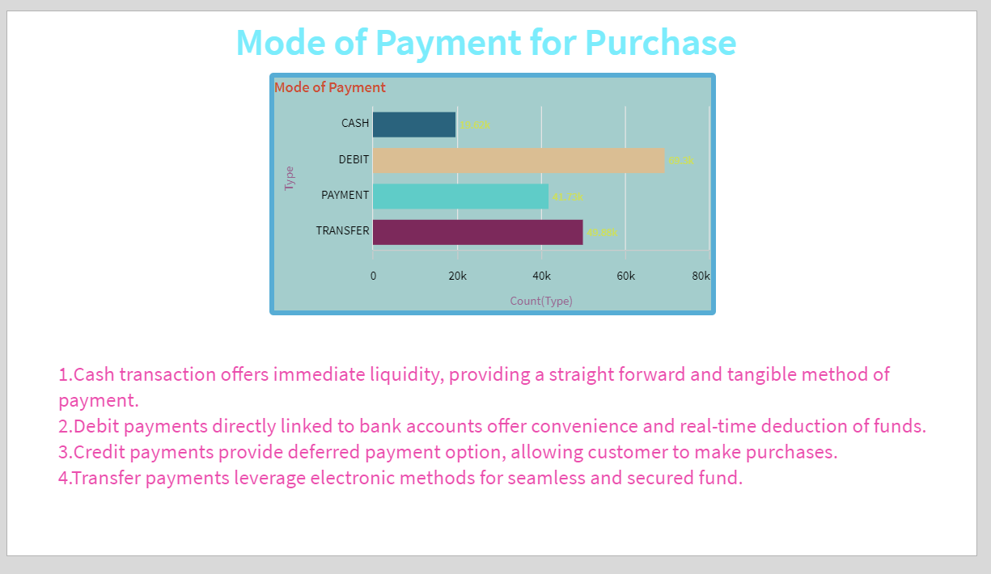

**Storytelling 4:**

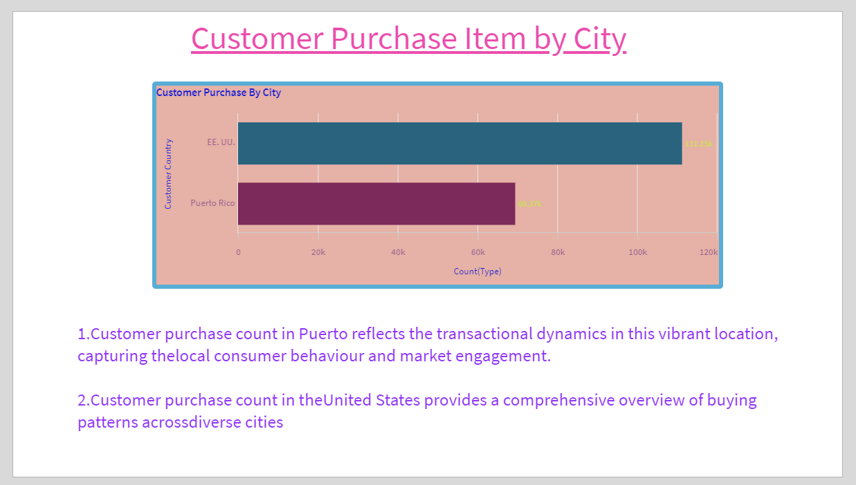

**Storytelling 5:**

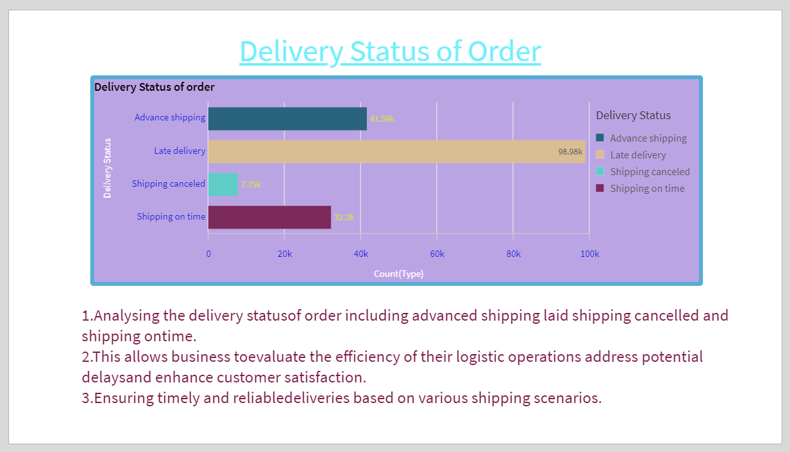

**Storytelling 6:**

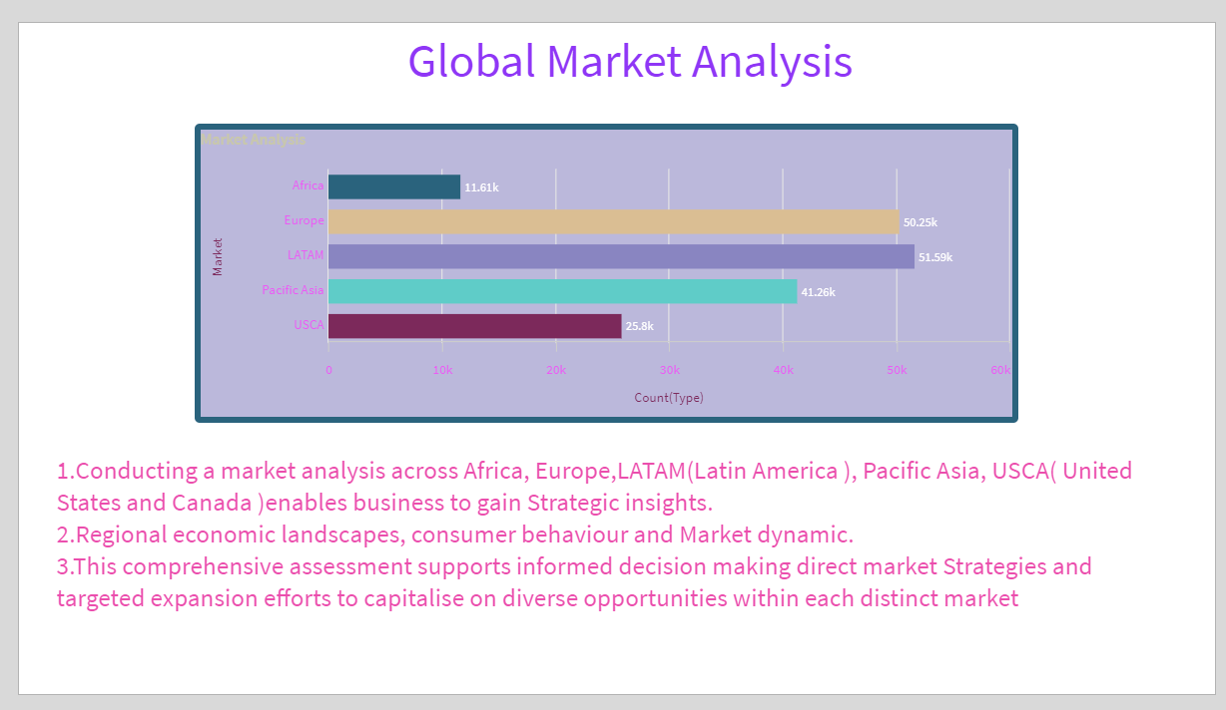

**Performance Testing:**

**Amount Of Data Loaded:**

The amount of data loaded in the qlik cloud was totally 2 tables and 54 fields and there are total 180519 rows and 54 columns.

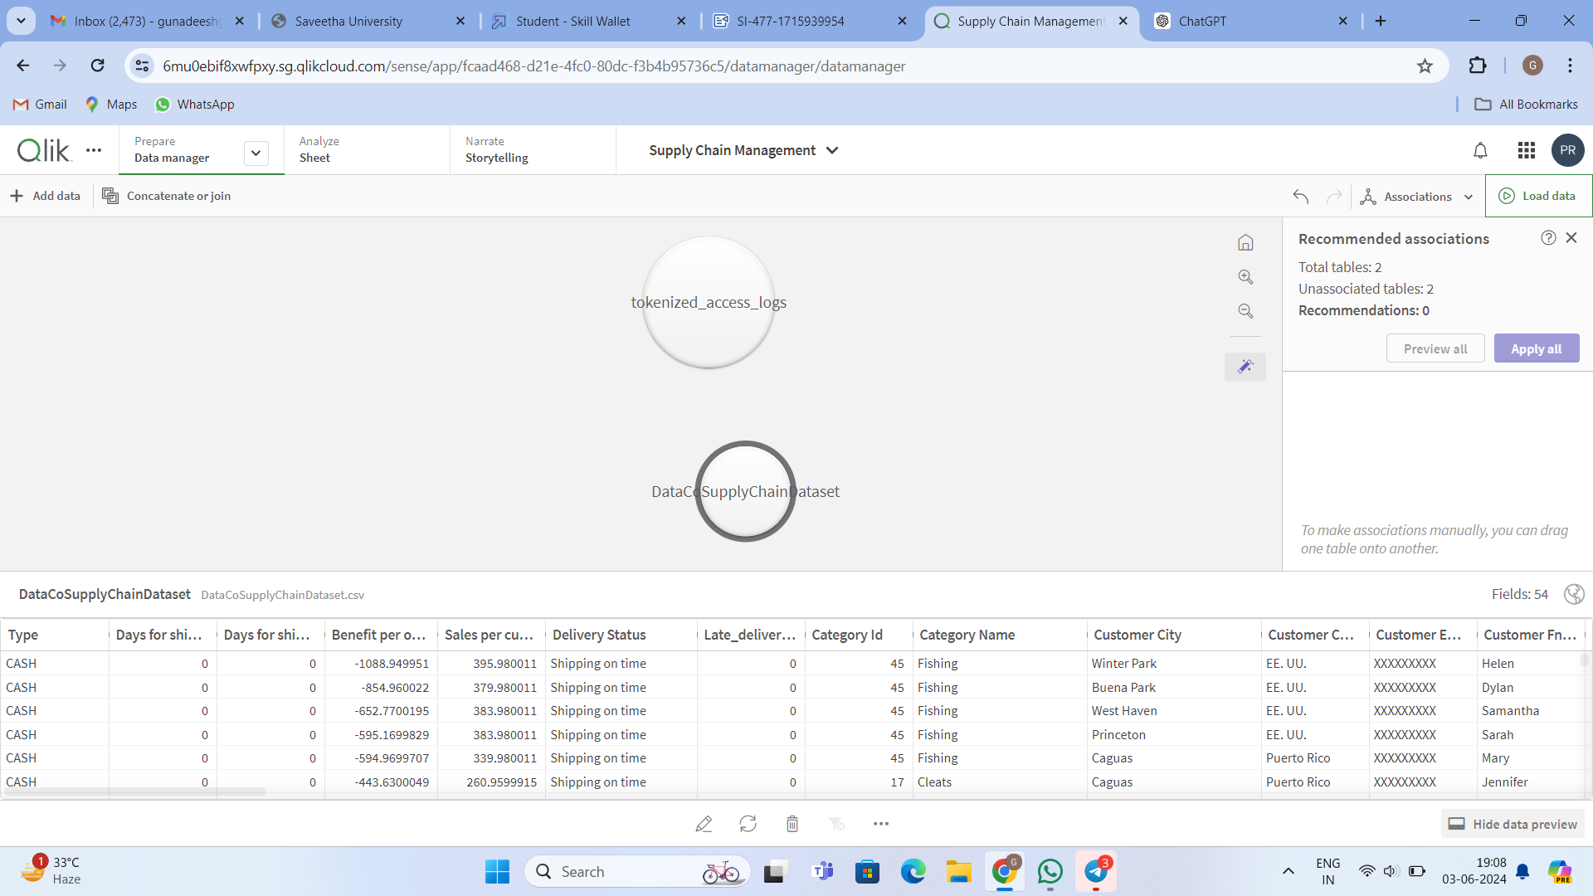

**Utilization Of Data Filters:**

There are lot of data filters being used such as to styling the KPIS,Bar charts ,Histograms,etc which used above visualization which different measures such as sales,delivery risk,Profit Margin etc w hich styling is done by corner radius with the color and the text font colorand text font size of main title and filters such as to change the different color to their Bar charts and provide them a new color and look more visualization.

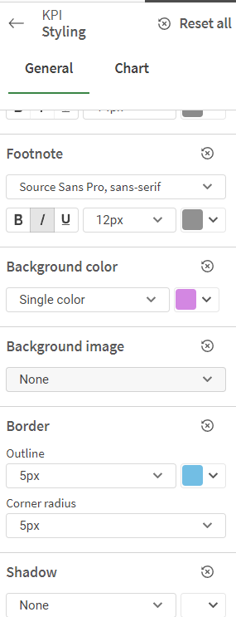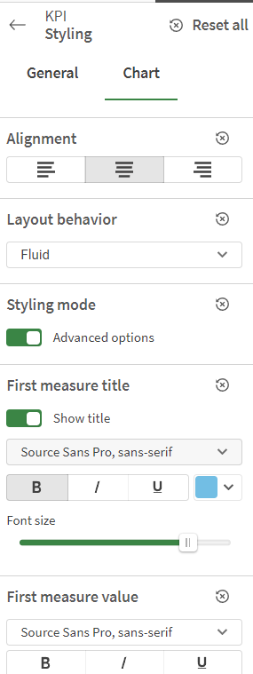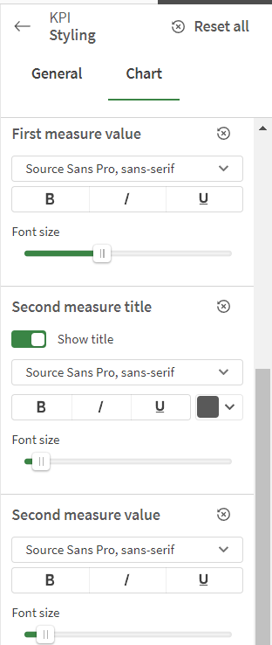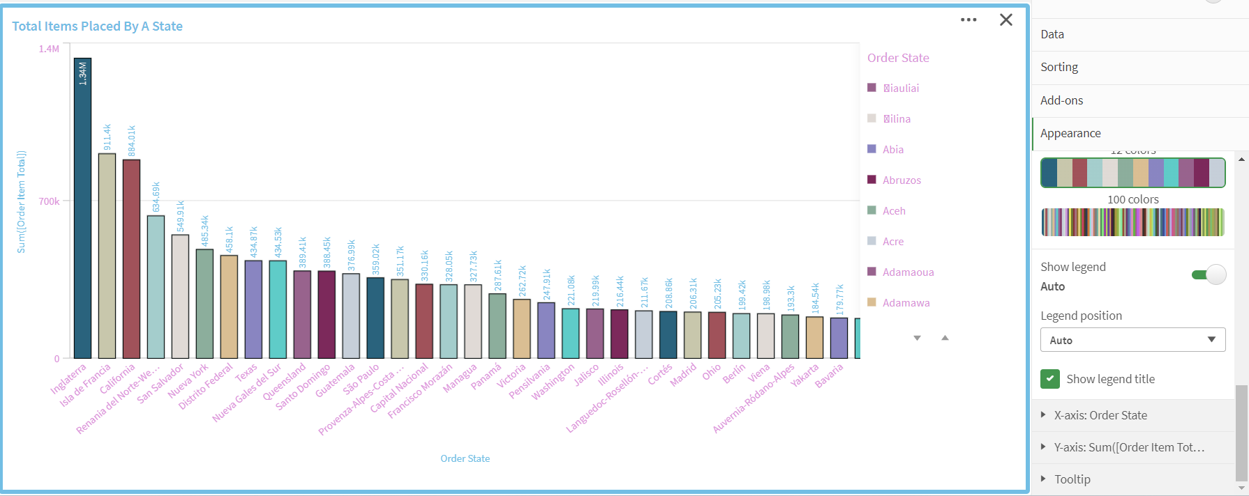

**No Of Visualizations/ Graphs:**

Data Visulaiazations have been done for the following one:

1. Global Profit Ratios
2. Total Items placed by customer in country
3. Total Items placed by a state
4. Analysis on customer segment
5. Mode of payment
6. Customer purchase by city
7. Delivery status of orders
8. Analysis on benefit per order
9. Analysis on profit ratio
10. Market Analysis
11. Analysis on order region

**Conclusion:**

This project marks a significant step toward revolutionizing supply chain management by harnessing the power of Qlik's advanced analytics capabilities. Through the integration of comprehensive data aggregation, dynamic visualization, and real-time tracking, this initiative seeks to transform traditional supply chain processes, ensuring greater efficiency, responsiveness, and adaptability.

The extensive literature survey underscores the pivotal role of data-driven insights in optimizing logistics, forecasting, and inventory management. Successful implementations across various industries highlight the tangible benefits, including enhanced operational efficiency, reduced lead times, and minimized transportation costs. However, the adoption of such innovations also necessitates robust data governance frameworks and a cultural shift toward data-driven decision-making.

The social impact analysis reveals that data-driven supply chain management can significantly improve social welfare programs and financial inclusion, demonstrating its potential to contribute positively to society. Meanwhile, the business impact analysis confirms substantial benefits across sectors, notably in banking, telecommunications, and e-commerce, with marked improvements in sales, customer onboarding, and operational efficiency.

In conclusion, this project aims to elevate supply chain management to new heights, fostering a more proactive, informed, and efficient operational landscape. By leveraging Qlik's advanced analytics, organizations can achieve significant advancements in their supply chain operations, ultimately driving better business outcomes and contributing to broader societal benefits.